خطوة
KHUTWA
SMAC 2026 · DEMO DAY PACK
PERSONAL COPY · MAY
Tuesday, 16 September 2026 · Khalifa University
School Students Category
May Ahmed Mourad · AI & Data Lead (you)
Shamsa Faris Al Mazrouei · Core App Lead

IN THIS PACK
1 — The Official Scoring Rubric
2 — The Day, Mapped to the Agenda
3 — Booth Setup
4 — The 15-Second Hook
5 — The Full Booth Script
6 — Judge Q&A Prep
7 — If Something Goes Wrong
8 — Tonight, Before You Sleep
The headline: Knowledge & GitHub Check is 35% of the score — the single biggest category — and 25 of those points are the Q&A alone. Explaining the app well matters more than anything else on the rubric.

PART 1 The Official Scoring Rubric
Keep this in mind all day. Final score out of 100, across four categories:
Category | Weight | Breakdown
Idea & Theme Relevance | 20% | Idea originality and usefulness — 10%  Relevance to the theme — 10%
Implementation & Usability | 25% | User interface / user-friendliness — 10%  Functionality — 15%
Application Quality | 20% | Mobile app realization (renders correctly on a real phone) — 10%  Performance & reliability (works consistently, not flaky) — 10%
Knowledge & GitHub Check | 35% | GitHub repository & development evidence (commits, history, team contributions) — 10%  Q&A session (you explaining the app) — 25%
Knowledge & GitHub Check is the largest category by far, and note from the organizers: an app can be excluded entirely if it isn't relevant to the theme.
Rules that matter most for tomorrow
— AI must NOT generate the full application. AI may only be a documented supporting tool — every use logged with the prompts and how the output was used. (Already covered in docs/ai-prompt-log.md and docs/AI-USAGE-REPORT.md.)
— It must be a downloadable mobile app, not a web app — the APK and the “how to try it” QR codes on the poster directly serve this.
— Winners are the top two teams in each of two categories: Undergraduate students, and School Students. You're in the School Students category.
— No outside help during the competition; no discussion between competing teams.
What this means practically
The live demo (Implementation/Usability + Quality, 45% combined) matters, but the Q&A alone is 25% — more than the entire “Implementation and Usability” category. Don't let device or network trouble eat your Q&A time. If the app misbehaves, fall back to the video or poster fast and protect the conversation.

PART 2 The Day, Mapped to the Agenda
Time | Activity | What to do
9:00 – 9:30 | Registration, meet & greet | Set up the booth.
9:30 – 9:45 | UG Admission Presentation | Attend or hold the booth; not demo-critical.
9:45 – 10:00 | PG Admission Presentation | Same as above.
10:00 – 12:00 | Booth Visits by Judges | BOTH of you at the booth. Full script, every visit.
12:00 – 1:00 | Lunch | Eat in shifts if judges are still around; never leave the booth unstaffed during a visible pass.
1:00 – 2:30 | Judge Visits (Continued) | BOTH of you at the booth.
1:00 – 2:00 | Workshop “AI Around Us” (overlaps) | You don't know whether School Students judging lands in window 1 or 2 — treat both as live. Skip the workshop, or have one of you duck out only if the booth is quiet and the other can run the script solo.
2:30 – 3:30 | Judge Discussions & Deliberations | You're not needed.
3:30 – 3:35 | Inspirational Talk, CS Dept. | Attend together.
3:35 – 4:00 | Winners' Announcement | Attend together.
Judges split across two categories in the same two windows, so you can't assume which window is “yours.” Stay booth-ready for both 10:00–12:00 and 1:00–2:30 — full script, both of you.

PART 3 Booth Setup
Do this at 9:00.
☐ Poster mounted, both QR codes (GitHub, APK) visible and unobstructed.
☐ Phone A (Android) — APK installed, signed in, family already created/joined (no first-run auth live), all 8 stories unlocked, charged to 100%, brightness up, Do Not Disturb on.
☐ Phone B (iOS, if available) — Expo Go installed. Confirm before 10:00 whether “npx expo start --tunnel” actually reaches it on the venue network. If it doesn't reliably connect, don't attempt it live — only if a judge specifically asks about iOS, and say so honestly.
☐ Laptop nearby, logged into the GitHub repo, with docs/AI-USAGE-REPORT.md and docs/ai-prompt-log.md open in tabs as backup.
☐ The submission video ready to play in one tap as a fallback.
☐ Both of you have skimmed docs/architecture.md once tonight — the Q&A (25% of the total score) can land on either of you, on any file.
Note on the poster's screenshots
The poster shows the score at 59 with 3 of 8 stories unlocked — that was the state when the poster was made. The live demo phone now has all 8 stories unlocked, so what you show live looks further along than the poster.
“That's an earlier snapshot — we've kept using the app since.”

PART 4 The 15-Second Hook
“Hi — this is Khutwa. It's a family walking app where you don't grow your own step count, you grow one shared tree with your family — and it tells you stories about the places you walk to. Want a 90-second walkthrough?”
PART 5 The Full Booth Script
About 3–4 minutes, judge-paced.
A · THE PROBLEM · May, ~20 sec → YOUR LINE
RUBRIC · Idea & Theme Relevance, 20%
“Movement and memory are fading together in the same families. People mean to walk together, but the time they actually spend active and together keeps shrinking. And separately, the everyday places and stories our grandparents carry mostly go unrecorded. Step apps are individual and competitive; heritage content is static — neither is built around the family.”
B · THE IDEA · May, ~20 sec → YOUR LINE
RUBRIC · Idea & Theme Relevance, 20%
“So Khutwa is built around one family, one shared tree — a Ghaf, the UAE's national tree, which survives the desert by sending its roots deep. Every step your family takes together waters it. The walk is the reason to be together — not the goal.”
C · LIVE DEMO · Shamsa, ~90–120 sec
RUBRIC · Implementation & Usability, 25% · Application Quality, 20%
Hand the phone to the judge if they want to hold it.
1. Open the app on the family already signed in. Point at the tree: “This is our family's tree — it grows through six stages as our combined steps go up: seed, sprout, sapling, young, mature, ancient. Right now we're at [current stage].”
2. Scroll the score card: “One number, the Khutwa Score, built from three parts: Root is how much we move, Bloom is how much we do together, Heritage is how many of these places we've actually visited as a family.”
3. Tap into Stories: “Walking near a real heritage place — Qasr Al Hosn, the Grand Mosque, the Corniche — unlocks a short story about it, written ahead of time and read aloud on the phone. We've unlocked all eight for today.” Tap Play story on one and let a few seconds of narration play.
4. Show the bloom: “And when family members are actually together in the same place, the tree blooms — that's the moment the app is really built around.” Tap “We're together” on the Walk screen if the tree isn't already in bloom.
5. If they're not rushed, open the Family tab: invite code, location toggle, language switch — flip to Arabic for a second and back.
D · RESPONSIBLE AI & PRIVACY · May, ~30 sec → YOUR LINE
RUBRIC · Knowledge & GitHub Check, 35%
Don't skip this even if the judge is in a hurry — it directly answers the rubric's AI-documentation requirement.
“AI has exactly one job here: turn a heritage place and a family memory into a short spoken story. Every story is generated ahead of time, reviewed by us, and cached on the phone — there's no live AI call at runtime, and a family's real-time location never leaves their device or their family group. Every AI-assisted step we took building the app — scaffolding, the Firebase layer, the scoring logic, the story generation — is logged with the actual prompts in the GitHub repo, per the competition rules. Either of us can open any file and explain it.”
E · EVIDENCE & CLOSE · whoever hasn't been talking, ~15 sec → COULD BE YOU
RUBRIC · Knowledge & GitHub Check — GitHub evidence, 10%
“It's React Native and Expo, Firebase for auth and data, and it's typechecked and unit-tested — the scoring logic ships with real test coverage, not just a demo. Both QR codes on the poster are live: one goes straight to the GitHub repo — commits, code, the AI prompt log — the other downloads the Android app directly, free, no account. Khutwa — every step waters the story.”
PART 6 Judge Q&A Prep
Q How is AI actually used?
A One narrow job — pre-written heritage narration, team-reviewed, cached on-device. No live inference, no runtime AI calls. Point at docs/AI-USAGE-REPORT.md and the prompt log.
Q Isn't the AI part small? Could this exist without AI?
A The walk-together mechanic could; the heritage storytelling — turning a family's presence at a place into a warm, spoken, family-specific narrative — is the AI's job, and it's core to the theme (family bonds and culture), not bolted on.
Q What about privacy and location tracking?
A Location is processed on-device only, used solely to unlock nearby stories and detect togetherness. Never leaves the family group, never sent to any AI service or third party. Each member has their own sharing toggle on the Family tab.
Q Why a tree, why the Ghaf specifically?
A National tree of the UAE, survives by rooting deep and sheltering life around it — a direct metaphor for a family staying connected, not a generic gamification skin.
Q How is the Khutwa Score calculated?
A Three sub-scores — Root (movement), Bloom (togetherness), Heritage (culture) — each 0 to 100 on a rolling 7-day window, averaged into one number. Growth stages: seed 0–9, sprout 10–24, sapling 25–44, young 45–64, mature 65–84, ancient 85–100. Early stages come fast on purpose, to hook new families; ancient is deliberately hard.
Q Can I download it right now?
A Yes — scan the Android QR, or hand them the phone. If they have an iPhone and ask specifically, explain the Expo Go / tunnel route honestly, and that standalone iOS needs a paid Apple Developer account, out of scope for a student build.
Q What's the tech stack, and did you build it yourselves?
A React Native + Expo/TypeScript, Firebase (Auth + Firestore), expo-sensors/location/speech, EAS Build. Both of you can walk through any file — the codebase is intentionally kept understandable, not just functional, for exactly this Q&A.
Q How do we know this was actually built by you and not generated wholesale?
A The GitHub history — incremental commits over weeks, from scaffolding to design to scoring logic, each with what changed and why; the AI prompt log showing exactly where AI assisted and where the team wrote or reviewed the result themselves.
Q What would you build next?
A More emirates and heritage places, family photo memories pinned to a place, elder-recorded audio alongside the AI narration, Android Health Connect integration.
Q What was hardest, or what did you learn?
A Personalize this honestly — an authentic answer beats a rehearsed one. Fair starting point: getting the AI narration to feel warm and specific instead of generic tour-guide copy, and deciding early that location would never touch an AI service, which shaped a lot of the architecture.
Q Who did what?
A May — AI and data: story pipeline, scoring logic, Firebase, bilingual layer. Shamsa — core app: navigation, screens, location service, UI. Say it plainly; both of you should be able to explain the other's part too.

PART 7 If Something Goes Wrong
— No reliable network or hotspot flaky: the Android app is standalone once signed in — it only needs a connection for live Firestore reads and caches the last state. If fully offline, narrate over the poster screenshots and play the submission video instead.
— Phone won't connect for the iOS / Expo Go demo: don't fight it live. Say plainly — “iOS needs Expo Go and a tunnel connection, happy to try it, but the Android app is the reliable one to hand you right now” — and offer the Android phone instead.
— A judge is clearly on a tight 60-second pass: compress to the hook + one live screen (tree + score) + one line on privacy. Don't try to cover everything.
— App crashes or shows an error: stay calm, say “let me reload,” pull-to-refresh or relaunch. If it happens twice, switch straight to the video.
PART 8 Tonight, Before You Sleep
1. Run through this script once, out loud, together — 5 minutes.
2. Confirm the Android APK install (fresh install, not just Expo Go) works end-to-end: sign-in, family, tree, a story playing.
3. Test “npx expo start --tunnel” plus Expo Go on whatever network you'll actually have tomorrow, if you plan to show iOS live at all.
4. Charge both phones to 100%. Charge the laptop.
5. Re-read docs/AI-USAGE-REPORT.md once each — the rubric weighs Q&A at 25%, the single biggest line item on the whole scorecard.
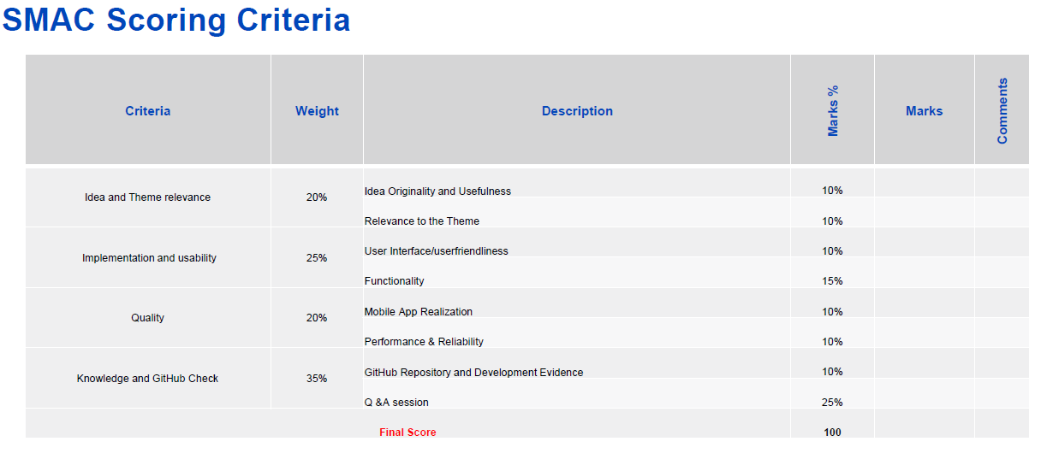
Good luck tomorrow — you're ready.

